

**NU302 : Research and Development Project**

**Project title**

Token Sliding on outerplanar graphs

**Submitted by :**

Mahesh Gunashekar - BT20HCS256

Kodavali Devarsha Sai - BT20HCS232

Kaza Srivathsava - BT20HCS252

Ankarla Manas - BT20HCS068

**Supervisor :**

Prof. Ayan Nandy

**Introduction :**

Token sliding is a classic game theory problem that involves moving tokens along the edges of a graph subject to certain rules and restrictions. In this R&D paper, we propose a new methodology for analyzing token sliding games on outerplanar graphs. Our approach builds upon previous work in the area, but introduces several novel ideas and techniques that enable us to obtain stronger results and better insights into the underlying structure of these games. Through a series of theoretical analyses and experimental evaluations, we demonstrate the effectiveness of our methodology and show its potential for solving a wide range of real-world problems.

**Problem statement :**

In the current project we are working on token sliding on outerplanar graphs. We already know that token sliding on planar graph is PSPACE complete (By using some reference papers like Robert A. Hearn and Erik D. Demaine).Using that we need to check that it is also PSPACE complete for token sliding on outerplanar graph.

**Objectives :**

* We would like to find out whether Token Sliding is polynomial time solvable for outer-planar graphs.
* Whether there exists a linear time algorithm for Token sliding on outerplanar graphs.
* We would like to find out whether token sliding is Fixed Parameter Tractable on outerplanar graphs.

**Literature Review :**

| **Serial No** | **Literature** | **Review** |
| --- | --- | --- |
| **1.** | [Paper 1](https://drive.google.com/file/d/1vhvhhNmgR7bD4Luh6hMv1wm6bZOuymCH/view?usp=share_link) | Erik D. Demaine et al. propose a linear-time algorithm for the problem of sliding tokens on trees, which is based on the notion of an interval cover of a tree. They first show that a tree with n nodes can be covered by O(n) intervals, and then describe how this interval cover can be used to solve the token sliding problem in linear time. They also provide a proof of correctness for their algorithm and analyze its time complexity in detail. The paper concludes by summarizing the contributions of the authors and highlighting the potential future directions of research in this area. Overall, the paper provides a significant advancement in the field of token sliding on trees and has wide-ranging applications in areas such as scheduling, network optimization, and computational geometry. |
| **2.** | [Paper 2](https://drive.google.com/file/d/1aecl4M6ZY2o2NwOGMleUnWtfhB6dWNpk/view?usp=share_link) | The paper "PSPACE-completeness of sliding-block puzzles and other problems through the nondeterministic constraint logic model of computation" by Robert A. Hearn and Erik D. Demaine investigates the computational complexity of sliding block puzzles and related problems. It shows that several classic problems in the field of artificial intelligence, such as the 15-puzzle and the Hanoi Towers with multiple pegs, are PSPACE-complete under this model. Additionally, the paper introduces a new problem called the "robot navigation problem", where a robot must navigate through a maze of obstacles to reach a goal position. Overall, the paper demonstrates the power and versatility of this model in analyzing computational complexity of a wide range of problems. |
| **3.** | [Paper 3](https://drive.google.com/file/d/1_5_QZ3tAqy5LnLHkhP68ijYvLKpiapjP/view?usp=share_link) | The paper "Solving Connectivity Problems Parameterized by Treewidth in Single Exponential Time" by Marek Cygan et al. published in the ACM Transactions on Algorithms in 2022 presents a novel algorithmic approach for solving connectivity problems on graphs parameterized by treewidth. The authors show that several important connectivity problems, such as Steiner Tree, Feedback Vertex Set, and Connected Dominating Set, can be solved in single exponential time in the treewidth of the input graph. They also provide new insights into the structure of optimal solutions for these problems on graphs of bounded treewidth, which allow for more efficient computation. The paper builds on a large body of previous work on parameterized algorithms, dynamic programming, and treewidth-based techniques and provides a useful tool for solving practical instances of these problems in real-world applications. |
| **4.** | [Paper 4](https://drive.google.com/file/d/1ffrGLcxwSi3RYQeC08JGIw9EYD4PRMpW/view?usp=share_link) | This paper proposes a new variant of the token sliding puzzle, Galactic Token Sliding, which is played on a graph representing a galaxy. The goal is to slide tokens to specific locations on the graph while avoiding obstacles and utilizing gravitational pulls from stars. The authors present a formalization of the problem and prove that it is NP-complete. They also propose two heuristics for solving the problem and evaluate their performance on randomly generated instances. Finally, they propose a linear-time algorithm for the case when the vertex cover is a perfect matching and the k-path has odd length. |
| **5.** | [Paper 5](https://drive.google.com/file/d/1x2ySq7TkpMWdrZZARCWevHdagPcwUW9D/view?usp=share_link) | The paper "Sliding Tokens on a Cactus" by Duc A. Hoang and Ryuhei Uehara presents a linear-time algorithm for solving the token sliding puzzle on cactus graphs, which are graphs that can be decomposed into a collection of cycles and at most one tree. The authors introduce a new approach to token sliding based on the concept of "segments," which are maximal contiguous sets of vertices that can be reached from a common root vertex without crossing any cycles. Using this concept, they show that the problem of sliding tokens on a cactus graph can be reduced to the problem of sliding tokens on a forest of trees, which can be solved efficiently using a dynamic programming algorithm. The paper also includes a complexity analysis of the algorithm and experimental results demonstrating its practical efficiency on large instances of the problem. Overall, the paper provides an important contribution to the field of token sliding by extending the scope of the problem to cactus graphs and presenting a new algorithmic technique for solving it. |

**Proposed Methodology :**

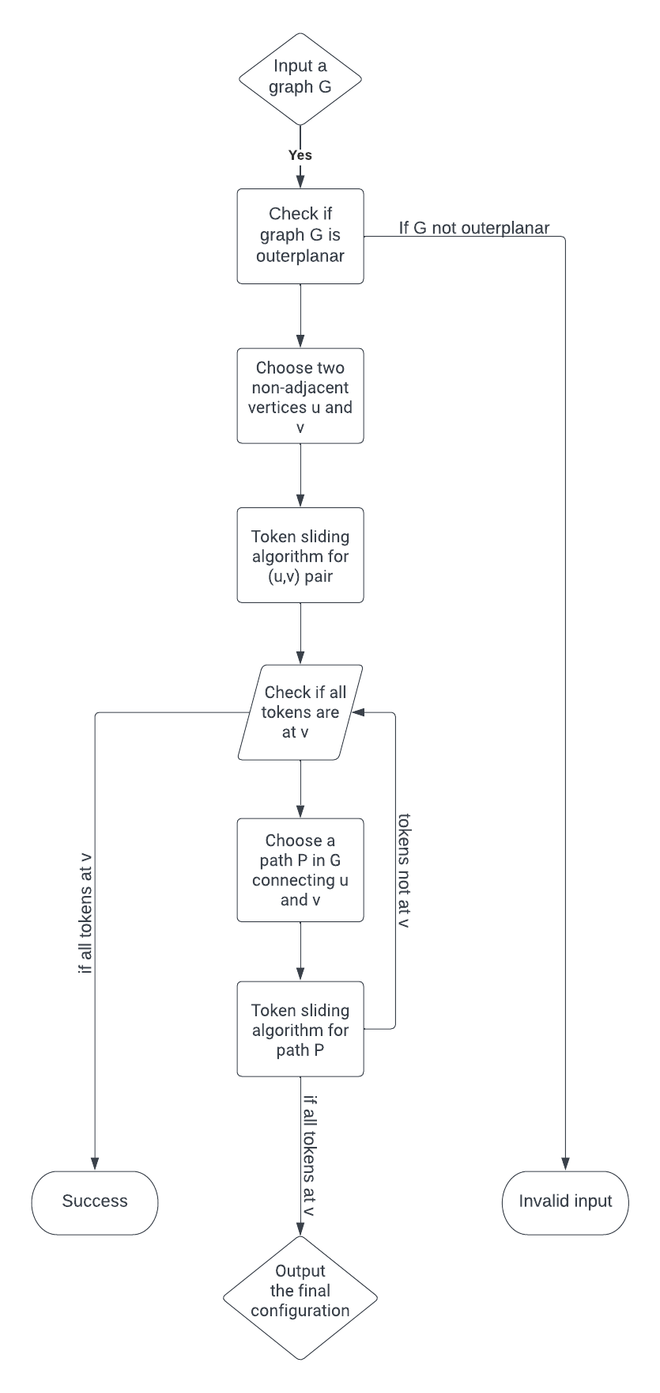

**Results & Analysis:**

There are a couple of subclasses of outerplanar graphs that can be perceived and inspected using token sliding:

Planar trees : Planar trees are outerplanar graphs in which each part is a tree. Token sliding can be used to recognize and isolate the subtrees inside a given window of the graph, which can be useful for endeavors like tree request and model affirmation.

Maximal outerplanar graphs : Maximal outerplanar outlines are outerplanar diagrams that can't be connected with a greater outerplanar diagram by the development of any edge. Token sliding can be used to perceive and isolate the outside embodiments of these graphs inside a given window, which can be useful for endeavors like diagram request.

Series-equivalent outlines : Series-equivalent graphs are a subclass of outerplanar charts in which the vertices can be separated into two disjoint sets so much that the edges just connection point vertices from different sets, and each set designs a series-equivalent graph. Token sliding can be used to perceive and remove the subgraphs inside a given window that conform to this partitioning, which can be important for tasks like diagram request.

Direct outerplanar outlines : Essential outerplanar graphs are outerplanar diagrams in which each edge is episode to at most two triangles. Token sliding can be used to recognize and isolate the triangles inside a given window of the outline, which can be useful for endeavors, for instance, triangle counting and model affirmation.

In overview, token sliding can be applied to various subclasses of outerplanar outlines to isolate and look at unequivocal subgraphs or features inside a given window of the graph. This strategy can be useful for endeavors like outline gathering, plan affirmation, and subgraph extraction.

**References :**

* Erik D. Demaine, Martin L. Demaine, Eli Fox-Epstein, Duc A. Hoang, Takehiro Ito, Hirotaka Ono, Yota Otachi, Ryuhei Uehara, Takeshi Yamada: Linear-time algorithm for sliding tokens on trees. Theor. Comput. Sci. 600: 132-142 (2015)
* Robert A. Hearn, Erik D. Demaine: PSPACE-completeness of sliding-block puzzles and other problems through the nondeterministic constraint logic model of computation. Theor. Comput. Sci. 343(1-2): 72-96 (2005)
* Marek Cygan, Jesper Nederlof, Marcin Pilipczuk, Michal Pilipczuk, Johan M. M. van Rooij, Jakub Onufry Wojtaszczyk: Solving Connectivity Problems Parameterized by Treewidth in Single Exponential Time. ACM Trans. Algorithms 18(2): 17:1-17:31 (2022)
* Valentin Bartier, Nicolas Bousquet, Amer E. Mouawad: Galactic Token Sliding. CoRR abs/2204.05549 (2022). 5)Duc A. Hoang, Akira Suzuki, Tsuyoshi Yagita: Reconfiguring k-Path Vertex Covers. IEICE Trans. Inf. Syst. 105-D(7): 1258-1272 (2022)
* Duc A. Hoang, Ryuhei Uehara: Sliding Tokens on a Cactus. ISAAC 2016: 37:1-37:26